ShopEzo Merchant Guide
How to run your stores on shopezo.ae, screen by screen.
This guide follows the merchant dashboard in the order you will usually use it: set up a store, add products, handle orders, and manage your account. Each section shows where to find the screen, what it is for, and the steps to use it.

What's inside
- 1. Getting started: Signing in, Dashboard overview
- 2. Stores: Your stores, Create a store, Store products, Add a product, Master catalog, Store settings
- 3. Orders: Orders, Order details
- 4. Customers and drivers: User management
- 5. Account and billing: Payouts, Subscription, Profile, Settings, Help & Support

1. Getting started

Signing in
Where: shopezo.ae → Sign in
Use the email and password of your merchant account. After signing in you land on the Dashboard. The left sidebar is how you move between every section in this guide.
How to use it
- Open shopezo.ae and click Sign in.
- Enter your merchant email and password, then click Sign in.
- You are taken to the Dashboard. Use the EN button at the top right to switch the language at any time.

Dashboard overview
Where: Sidebar → Overview
Your home screen. It shows how your business is doing at a glance.
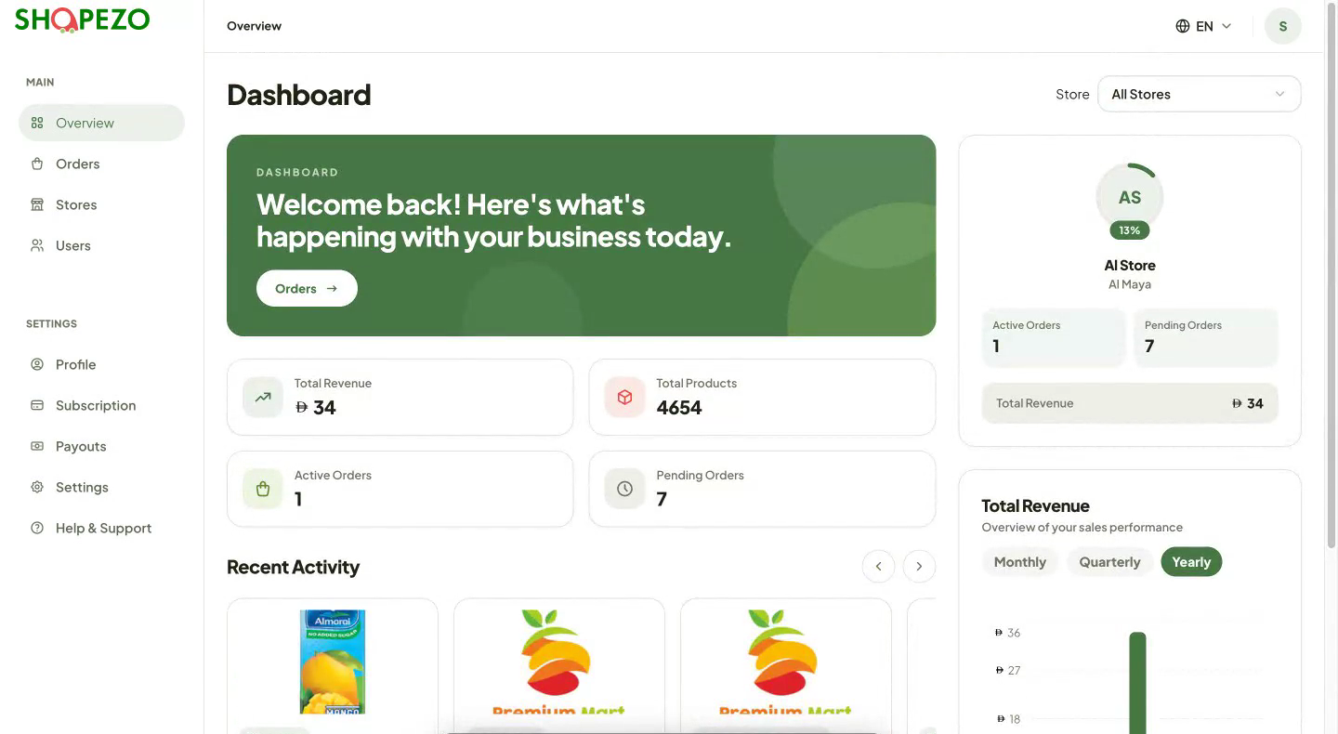
How to use it
- Read the summary cards: Total Revenue, Total Products, Active Orders and Pending Orders.
- Use the Store selector at the top right to see figures for one store or All Stores.
- Check Total Revenue and switch between Monthly, Quarterly and Yearly.
- Scroll down to Recent Activity and Recent Orders. Click an order to open it.
- Click the Orders button in the green banner to jump straight to your orders.

2. Stores

Your stores
Where: Sidebar → Stores
All the stores you run, shown as cards.
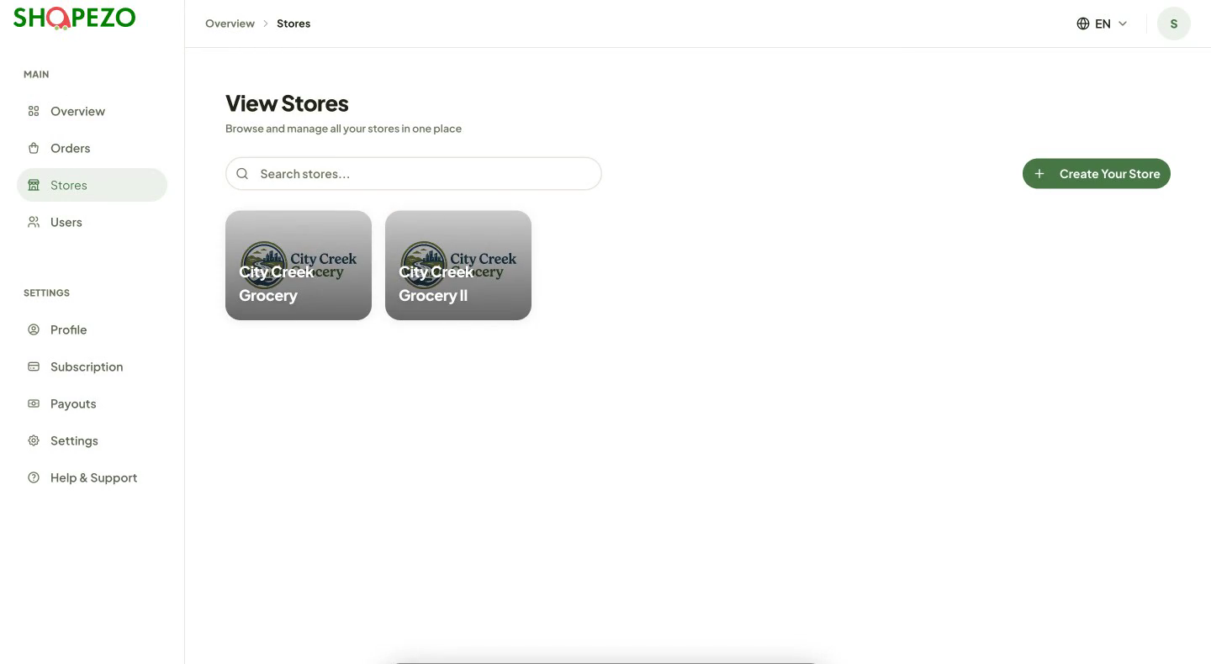
How to use it
- Search for a store by name with the search box.
- Click a store card to manage that store.
- Click Create Your Store to add a new store.
Note: A red badge on a store card means that store has no banners yet.

Create a store
Where: Stores → Create Your Store
Set up a new store in one short form.
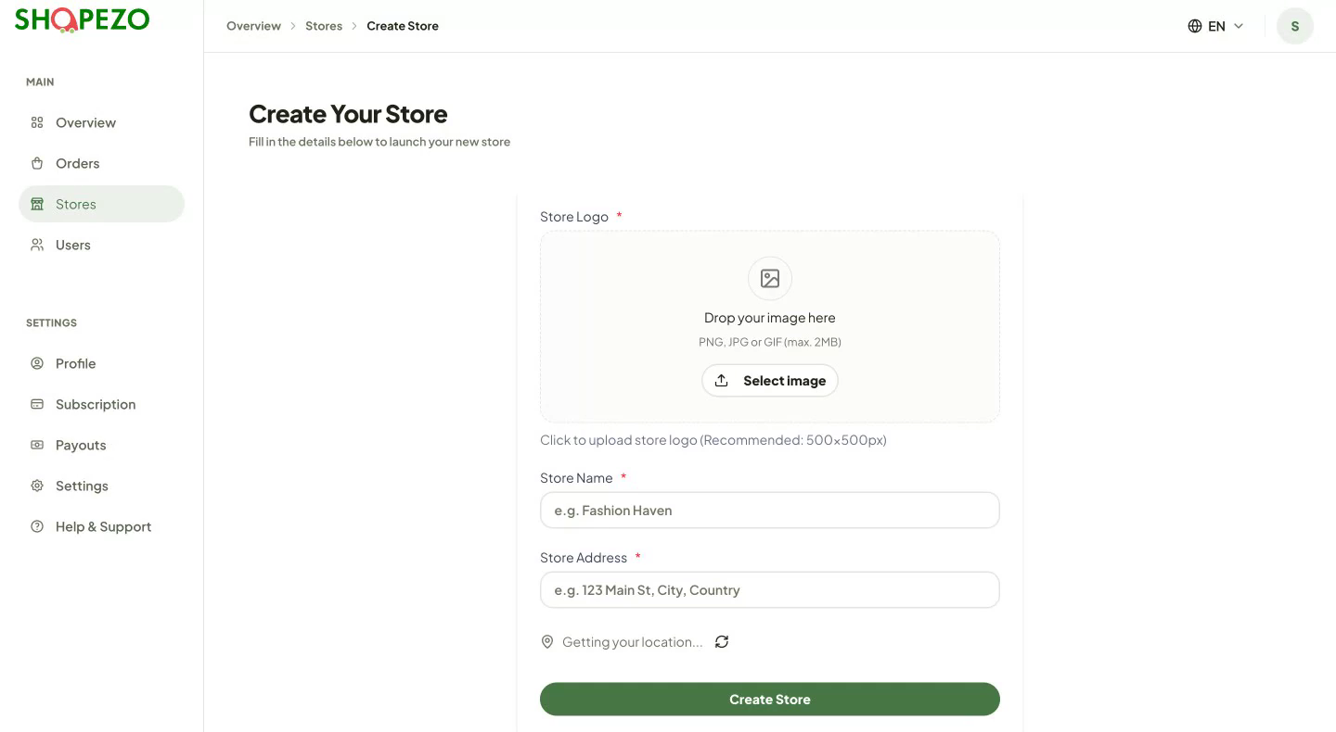
How to use it
- Upload a Store Logo (drag the image in or click Select image). A square image around 500 × 500 px works best.
- Enter the Store Name.
- Enter the Store Address, or let the page detect your current location.
- Click Create Store. The new store appears in your store list.

Store products
Where: Stores → click a store
The store page has three tabs: Shop Products, Shop Banners and Orders. Shop Products lists every product in the store with its image, name, description, price, stock, discount and size.
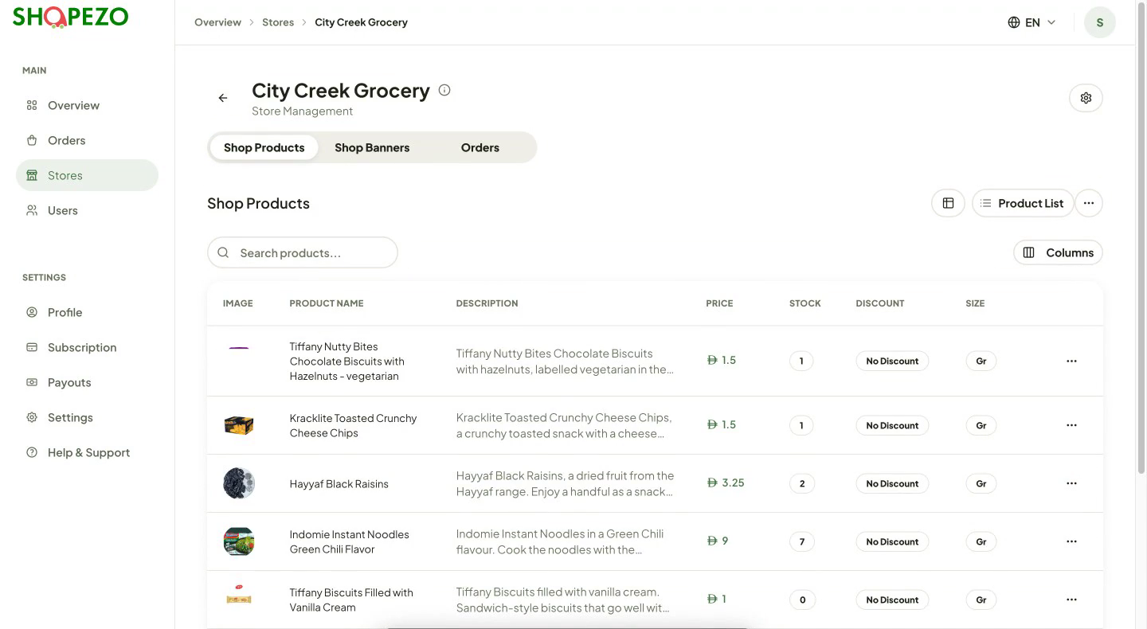
How to use it
- Search products with the search box.
- Use Columns to show or hide table columns.
- Use the ⋯ menu at the end of a row to manage that product.
- Click Product List to add items from the ShopEzo catalog, or the ⋯ button next to it for Add Product and Add Bulk Products (next two sections).
- Switch between table view and grid view with the view button.
- Open the Shop Banners tab to manage this store's promo banners, and the Orders tab to see only this store's orders.

Add a product
Where: Store page → ⋯ (next to Product List) → Add Product
Create a product of your own.
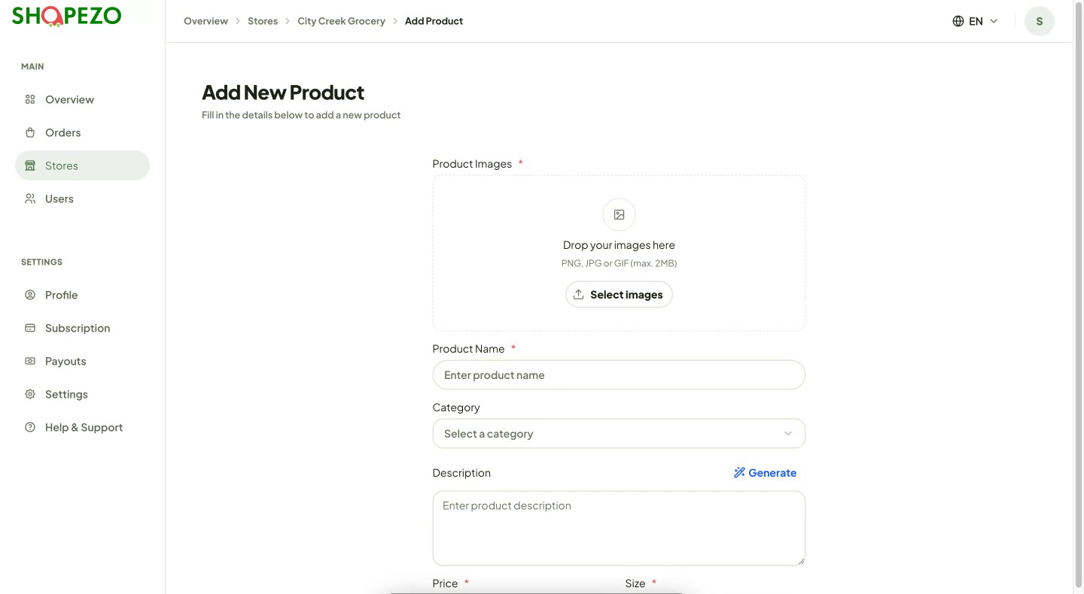
How to use it
- Upload one or more Product Images.
- Enter the Product Name and pick a Category.
- Write a Description, or click Generate to have one written for you, then edit it if needed.
- Enter the Price (AED), Size (for example S, M, L), Stock quantity and an optional Discount (%).
- Save the product. It appears in the store's product list.
Note: To add many products at once, choose Add Bulk Products from the same ⋯ menu and upload a CSV file.

Master catalog
Where: Store page → Product List
A ready-made ShopEzo catalog of common products. Adding from here is faster than typing products in yourself.
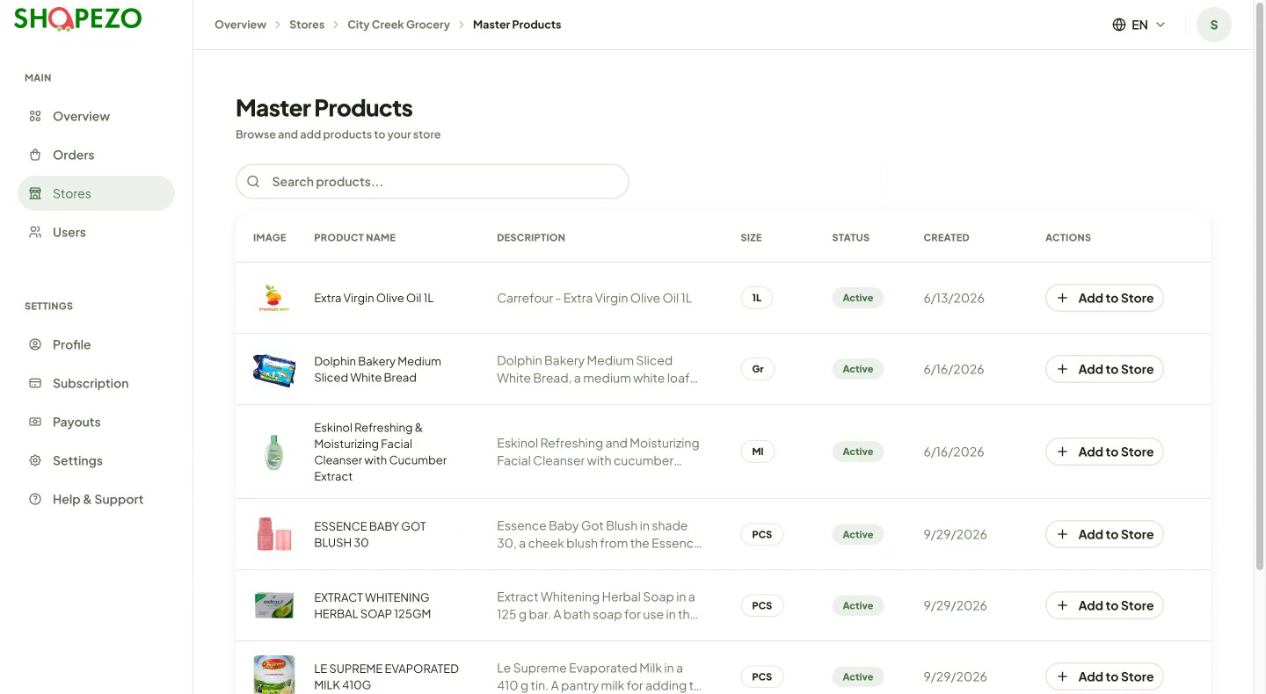
How to use it
- Search the catalog for the product you sell.
- Click Add to Store on its row.
- Fill in any details it asks for, such as your price and stock. The product is then listed in your store.

Store settings
Where: Store page → gear icon at the top right
Change how the store looks and where it is.
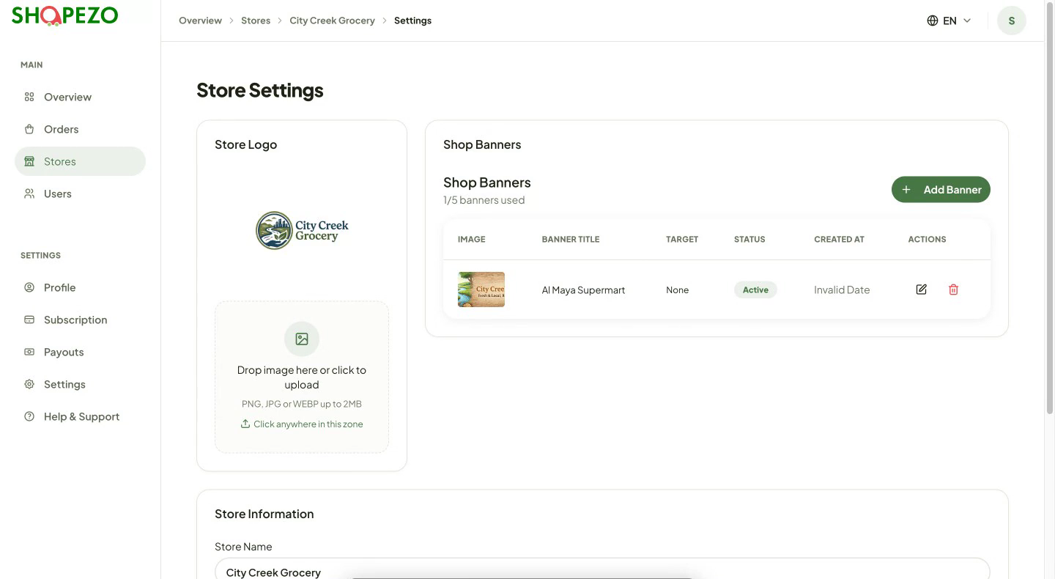
How to use it
- Store Logo: drag in a new image or click to upload (PNG, JPG or WEBP, up to 2 MB).
- Shop Banners: click Add Banner to add a promo banner (up to 5 per store). Use the edit and delete icons on each banner row.
- Store Information: change the Store Name and Address. Click Use current location or move the pin on the map.
- Click Save Changes.
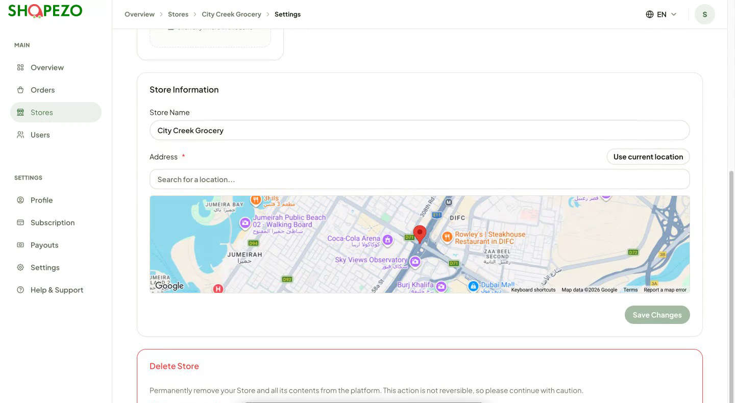
Note: Delete Store, at the bottom of the page, permanently removes the store and everything in it. It cannot be undone.

3. Orders

Orders
Where: Sidebar → Orders
Every incoming order across your stores, newest first. Each row shows the order ID, customer, store, total, status, assigned driver and date.
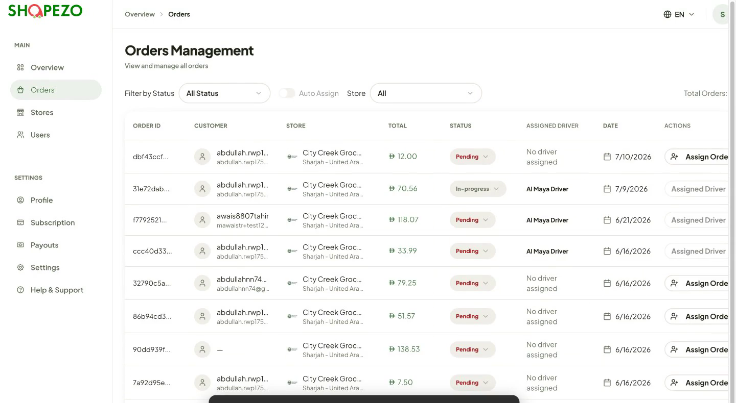
How to use it
- Use Filter by Status to show, for example, only Pending orders.
- Use the Store filter to show one store's orders.
- Turn on Auto Assign to have new orders assigned to drivers automatically.
- Click Assign Order on a row to choose a driver yourself.
- Click any row to open the full order.

Order details
Where: Orders → click an order
Everything about one order.
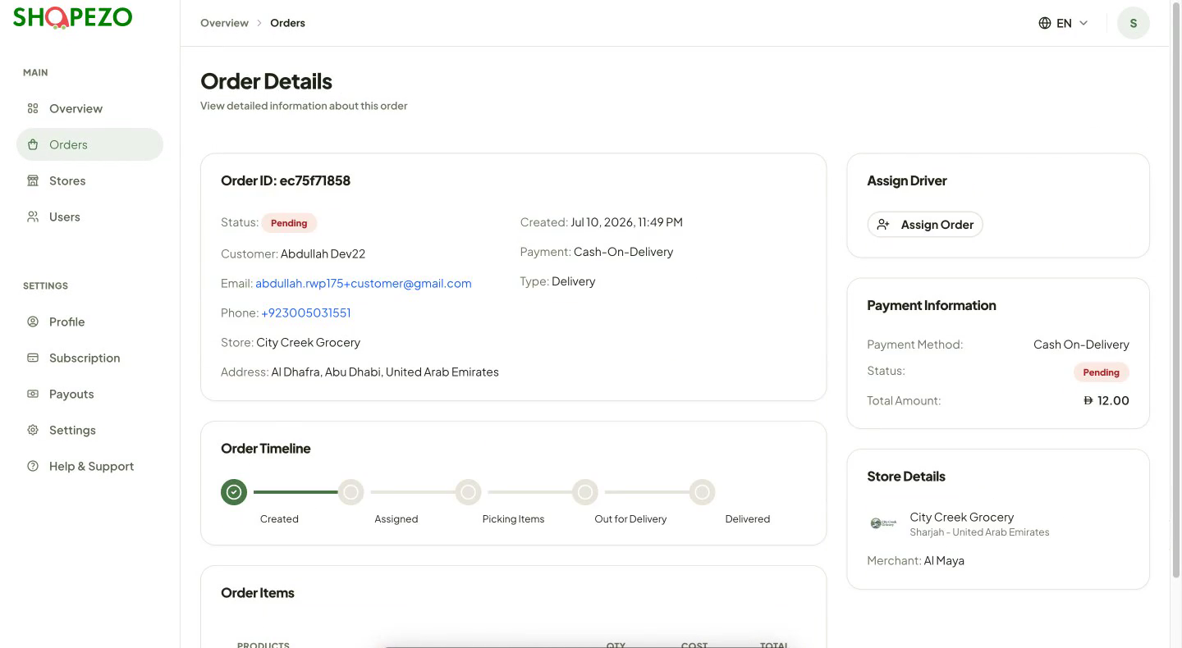
How to use it
- Check the order summary: status, customer name, email, phone, store, delivery address, payment method and order type.
- Follow the Order Timeline: Created → Assigned → Picking Items → Out for Delivery → Delivered.
- Review Order Items: each product with quantity, price and the order total.
- Use Assign Driver to send the order to a driver.
- Check Payment Information (method, status, total amount) and Store Details on the right.
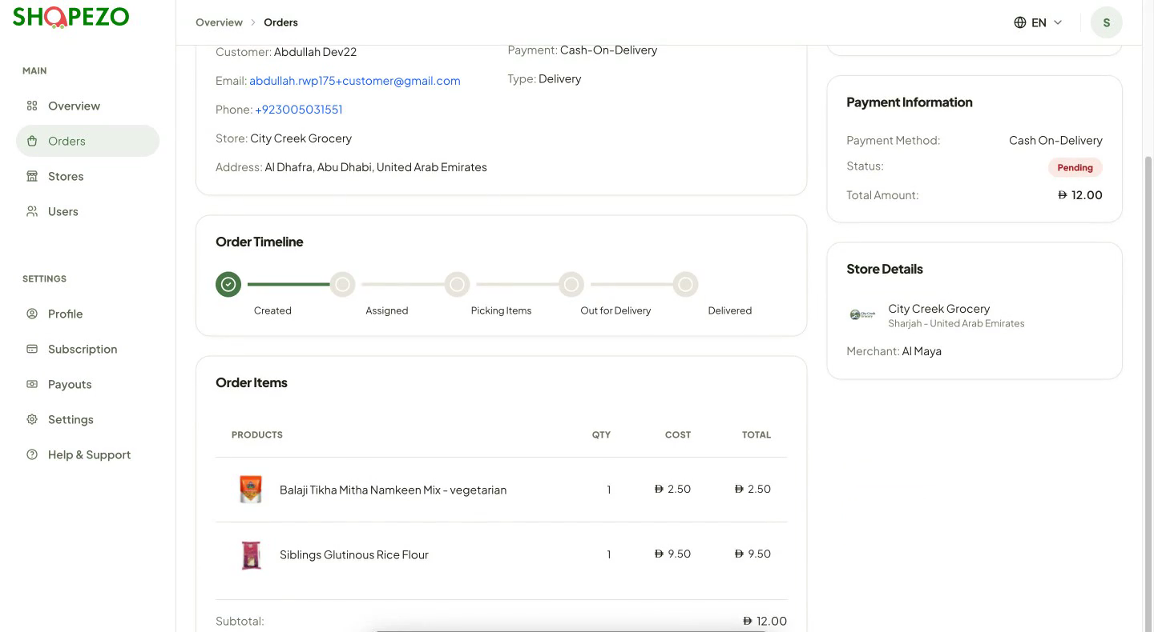

4. Customers and drivers

User management
Where: Sidebar → Users
The customers and drivers linked to your stores, with their contact details, verification, role, location and status.
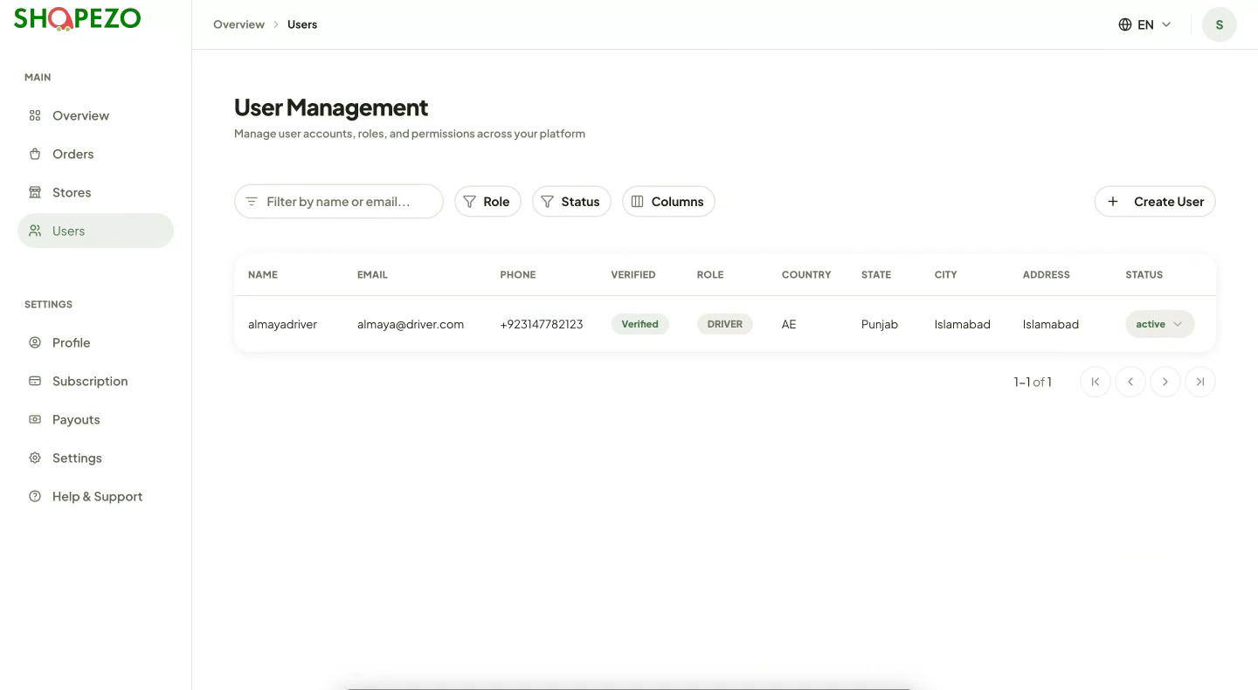
How to use it
- Filter by name or email with the search box.
- Use Role and Status to narrow the list, and Columns to choose what is shown.
- Click Create User to add a new user, such as a driver.

5. Account and billing

Payouts
Where: Sidebar → Payouts
Connect your Stripe account so money from your sales is paid out to you.
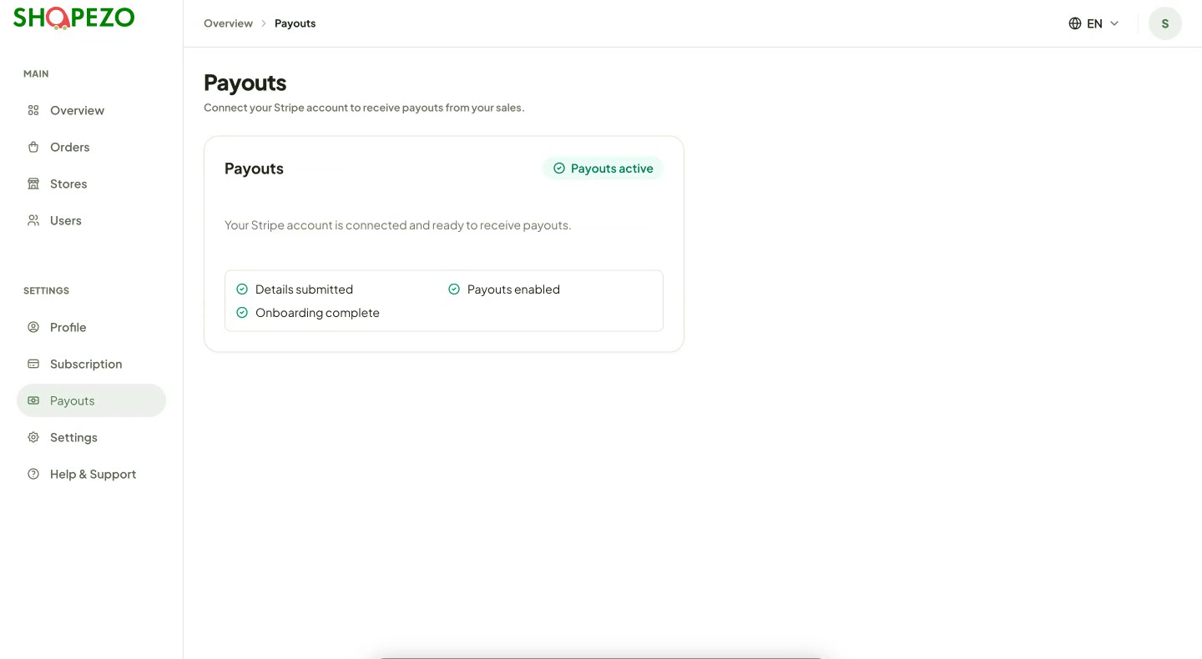
How to use it
- If you have not connected yet, start the Stripe setup from this page and complete the steps on Stripe.
- When everything is done you will see Details submitted, Onboarding complete, Payouts enabled and a green Payouts active badge.

Subscription
Where: Sidebar → Subscription
Your ShopEzo plan. The top card shows your current plan, billing cycle and expiry date.
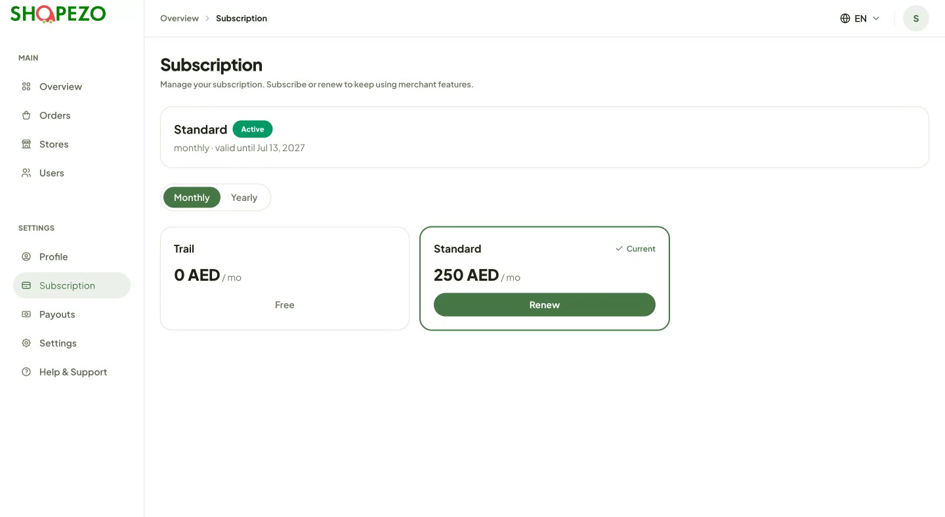
How to use it
- Switch between Monthly and Yearly to compare prices.
- Compare plans: Trial (free) and Standard (250 AED per month).
- Click Renew on your current plan to extend it before it expires.

Profile
Where: Sidebar → Profile
Your account and business details.
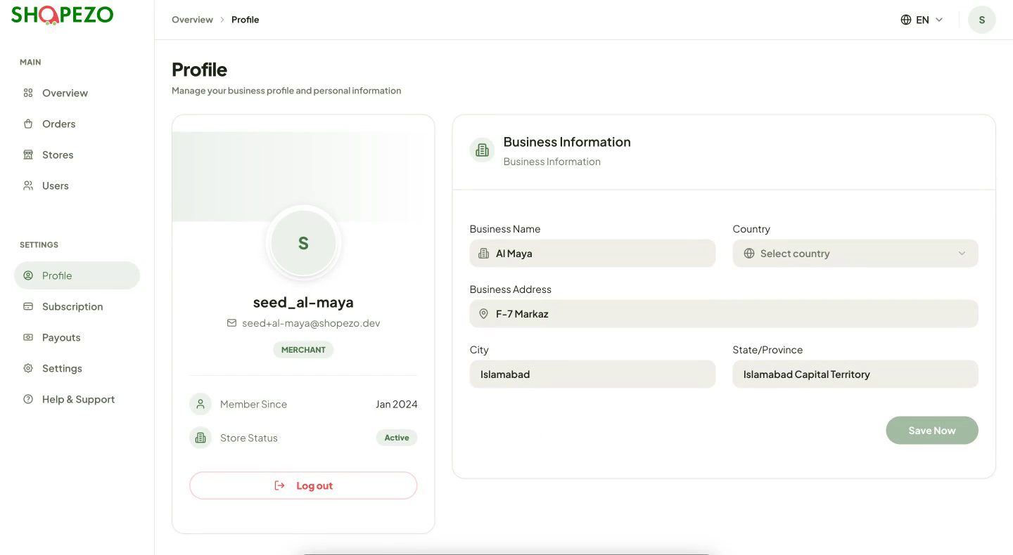
How to use it
- Check your account card on the left: username, email, role, member since and store status.
- Update Business Information: Business Name, Country, Business Address, City and State/Province.
- Click Save Now.
- Use Log out on the left card to sign out.

Settings
Where: Sidebar → Settings
Choose the language of the dashboard.
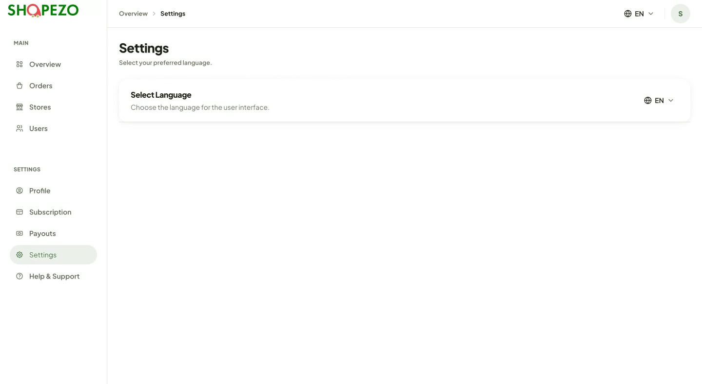
How to use it
- Under Select Language, choose English or Arabic.

Help & Support
Where: Sidebar → Help & Support
Answers to common questions and how to reach the ShopEzo team.
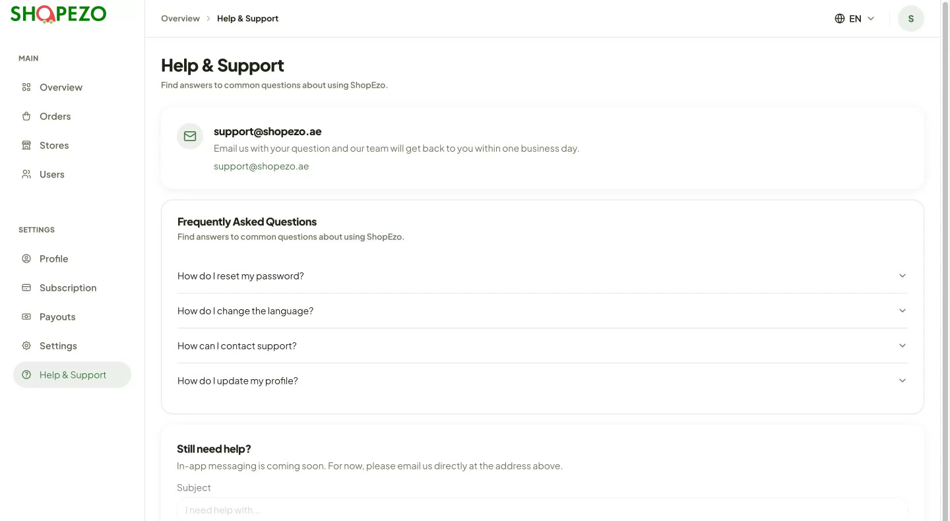
How to use it
- Read the Frequently Asked Questions (password reset, language, contacting support, updating your profile).
- Email support@shopezo.ae. The team replies within one business day.

Need help?
Email support@shopezo.ae or open Help & Support from the sidebar. The team replies within one business day.

